**Scheduling the built in Jenkins**

What Jenkins used is a cron expression, the different fields are :

1. MINUTES Minutes in one hour (0-59)
2. HOURS Hours in one day (0-23)
3. DAYMONTH Day in a month (1-31)
4. MONTH Month in a year (1-12)
5. DAYWEEK Day of the week (0-7) where 0 and 7 are sunday

If you want to schedule your build every 5 minutes, this will do the job : */5 * * * *

If you want to schedule your build every day at 8h00, this will do the job : 0 8 * * *

|  |  |  |  |  |  |  |  |  |  |  |  |  |  |  |  |  |  |  |  |  |  |  |  |  |  |  |  |  |  |  |  |  |  |  |  |
| --- | --- | --- | --- | --- | --- | --- | --- | --- | --- | --- | --- | --- | --- | --- | --- | --- | --- | --- | --- | --- | --- | --- | --- | --- | --- | --- | --- | --- | --- | --- | --- | --- | --- | --- | --- |
| **CRON expression**  A CRON expression is a string comprising five or six fields separated by white space that represents a set of times, normally as a schedule to execute some routine.  Comments begin with a comment mark #, and must be on a line by themselves.   |  |  |  |  |  | | --- | --- | --- | --- | --- | | **Field** | **Required** | **Allowed values** | **Allowed special characters** | **Remarks** | | Minutes | Yes | 0-59 | * , - | - | | Hours | Yes | 0-23 | * , - | - | | Day of month | Yes | 1-31 | * , - ? L W | - | | Month | Yes | 1-12 or JAN-DEC | * , - | - | | Day of week | Yes | 0-6 or SUN-SAT | * , - ? L # | - | | Year | No | 1970–2099 | * , - | This field is not supported in standard/default implementations. |   In some uses of the CRON format there is also a *seconds* field at the beginning of the pattern. In that case, the CRON expression is a string comprising 6 or 7 fields.  Comma ( , )  Commas are used to separate items of a list. For example, using "MON,WED,FRI" in the 5th field (day of week) means Mondays, Wednesdays and Fridays.  Hyphen ( - )  Hyphens define ranges. For example, 2000-2010 indicates every year between 2000 and 2010, inclusive.  Percent ( % )  Percent-signs (%) in the command, unless escaped with backslash (\), are changed into newline characters, and all data after the first % are sent to the command as standard input. |

*Under the job configuration we can define various build triggers. Simple find the ‘Build Triggers’ section, and check the ‘ Build Periodically’ checkbox.  With the periodically build you can schedule the build definition by the date or day of the week and the time to execute the build.*

**The format of the ‘Schedule’ textbox is as follows:**

MINUTE (0-59), HOUR (0-23), DAY (1-31), MONTH (1-12), DAY OF THE WEEK (0-7)

*The letter H, representing the word Hash can be inserted instead of any of the values, it will calculate the parameter based on the hash code of your project name, this is so that if you are building several projects on your build machine at the same time, let’s say midnight each day, they do not all start there build execution at the same time, each project starts its execution at a different minute depending on its hash code. You can also specify the value to be between numbers, i.e. H(0,30) will return the hash code of the project where the possible hashes are 0-30*

**Examples:**

start build daily at 08:30 in the morning, Monday – Fridays:

* 30 08 * * 1-6

weekday daily build twice a day, at lunchtime 12:00 and midnight 00:00, Sunday to Thursday:

* 00 0,12 * * 0-5

start build daily in the late afternoon between 4:00 p.m. – 4:59 p.m. or 16:00 -16:59 depending on the projects hash:

* H 16 * * 1-5

start build at midnight, every Saturday:

* @midnight

or:

* 59 23 * * 6

every first of every month between 2:00 a.m. – 02:30 a.m. :

* H(0,30) 02 01 * *

To schedule your build every 5 minutes, this will do the job : */5 * * * * OR H/5 * * * *

To the job every 5min past every hour(5th Minute of every Hour) 5 * * * *

To schedule your build every day at 8h00, this will do the job : 0 8 * * *

To schedule your build for 4, 6, 8, and 10 o'clock PM every day - 0 16,18,20,22 * * *

To schedule your build at 6:00PM and 1 AM every day - 0 1,18 * * *

To schedule your build start daily at morning - 03 09 * * 1-5

To schedule your build start daily at lunchtime - 00 12 * * 1-5

To schedule your build start daily in the afternoon - 00 14 * * 1-5

To schedule your build start daily in the late afternoon - 00 16 * * 1-5

To schedule your build start at midnight - 59 23 * * 1-5 OR @midnight

To run a job on 9.30p.m. (at night) on 3rd of May then I ll write or 21.30 on 3/5/2011 - 21 30 3 5 *

Every fifteen minutes (perhaps at :07, :22, :37, :52) 0 - H/15 * * * *

Every ten minutes in the first half of every hour (three times, perhaps at :04, :14, :24) - H(0-29)/10 * * * *

Once every two hours every weekday (perhaps at 10:38 AM, 12:38 PM, 2:38 PM, 4:38 PM) - H 9-16/2 * * 1-5

Once a day on the 1st and 15th of every month except December - H H 1,15 1-11 *

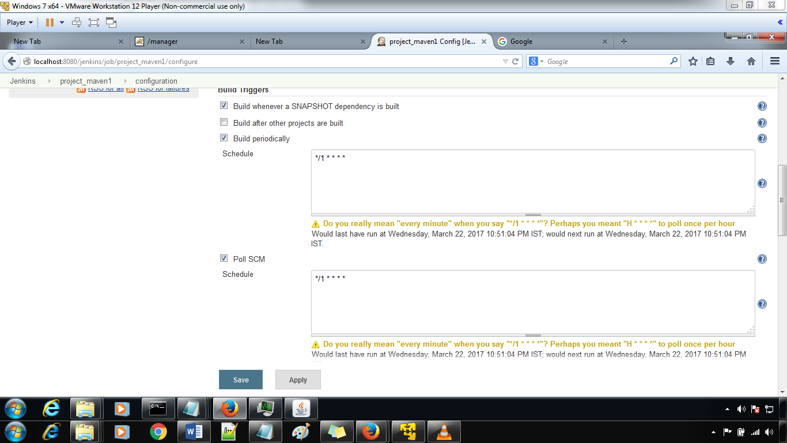

Check in the builttime

To disable the built Click the Disable Button for enabling enable button

